The Australian Blog
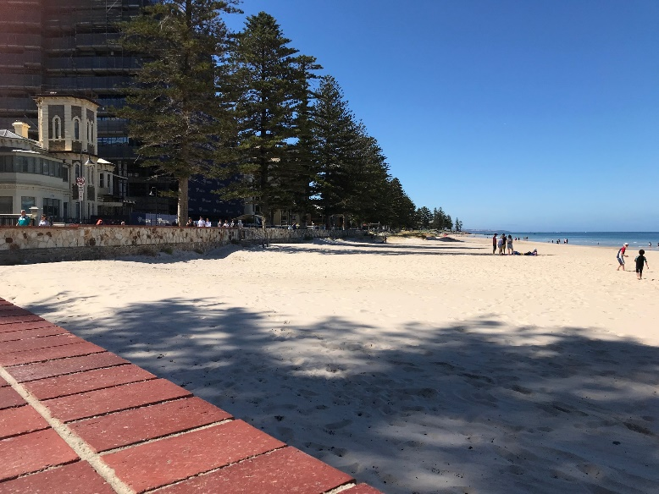
Adeleide
The 2020 Ayrshire World Conference started on Sunday 12th January. Quite a lot of the delegates arrived the night before so we had the great advantage of getting settled into the beautiful and luxurious hotel The Stamford Grand Adelaide. Some of the other delegates were not so lucky, due to appalling travel difficulties and delays in getting their luggage, they had a wait getting to the start of the Conference.
What a wonderful place to start a holiday of a life time. Our hotel was yards from a magnificent stretch of sandy beach, blue sea and a pier with various activities including Ladies volleyball. Along with the hot sunshine it was clear to see Genelg had a lot to offer a merry bunch of Ayrshire Farmers
For those wanting a little bit of culture there was a tram on the door step that went straight into the middle of Adelaide. This beautiful city has wide streets, some very high class shops exotic parks and fascinating museums tracing back the history of Adelaide from 200 hundred years ago.
Sunday Evening
This is where it all started on the first floor of the Stamford Grand with a Reception to welcome all the delegates and to be introduced to various VIPs and most importantly our Australian Hosts. A great many of the delegates knew each other and had met on previous world conferences. It was exciting meeting up with farmers from Canada Africa America New Zealand and of course the UK.
As we were introduced to various people and listened to how the next 18 days were going to pan out, excitement grew, our Australian hosts had obviously worked extremely hard to make this a World Conference to remember. Their attention to detail was really impressive. We each had a very comfortable and cool polo shirt with The Australian Ayrshire logo on. We were each given a very smart bag with our Itinerary, list of farms, maps and delegates. A boomerang, water bottles and a pen. Our coaches were colour coded and named after 3 Australian animals. The Yellow koala, the Blue Emu and the red Kangaroo. They even went to the trouble to give us all colour coded bag labels to go on our luggage so the bus drivers wouldn’t get them mixed up. Along with our name badges saying who we were and where we came from we were ready for off!!!!!

Monday 13th January
After a really delicious breakfast we got on our coaches Greg Leoni and John hosted these coaches. With our very competent coach drivers we were in very safe hands to embark on our Australian adventure.
Our first stop was just a short one to take a look at the view over Adelaide, we then travelled up to Mount Lofty to a viewing platform that overlooked the whole of Adelaide. It was a magnificent view and here we had a treat, we saw our first koala up a tree. So exciting, he was quite high up and difficult to spot him but out came the cameras and iPhones to capture this gorgeous creature.
We then were back on the busses and off to the town of Hahndorf, the oldest German settlement in Australia. It was a beautiful old town with some interesting shops. We had lunch at The Old Mill. It was an amazing buffet with every type of dish imaginable. We certainly didn’t starve! It was very hot. The tree lined street did offer a little shade which was very welcome
We then entered a wine region at Langhorne Creek. We saw the vines growing in long rows on the way. We stopped at a Winehouse for a wine tasting which was very pleasant and they also served afternoon tea. Feeling a little sleepy we drove back to Glenelg for a dip in the sea before dinner and BED!!!!

Tuesday 14th January
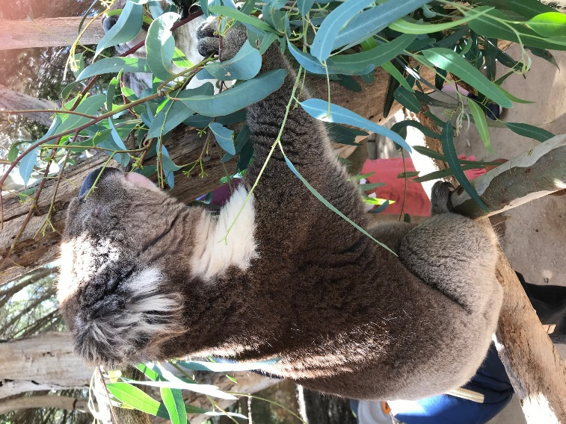
Feeling very refreshed we boarded our coaches and set off for Urimbirra Wildlife Park. Here we got very close up to the Australian animals which was a real thrill for everyone, we were given food we could give to the kangaroos, there we were in the paddocks feeding and stroking the kangaroos it was sheer bliss. We wondered a bit further to meet up with the Koalas. We were allowed to stroke their backs which was a treat. They really do look so cuddly!!! We saw some very handsome looking crocodiles with big teeth.. There was a variety of birds were so colourful especially the Rainbow Lorikeets. The shop did a sterling business that day on the sale of koalas and kangaroos. I think we were all besotted, a certain gentleman was always late back on the bus I think they should have left him with koalas, kangaroos and crocodiles!!!!!
We had lunch at Victor Harbour Bowling club. Here we had a fish and chip lunch. The view from the bowling club was spectacular lovely to be near the coast.
Our final visit of the day was to Geelunga the home of the Edmunds family. This was beautiful spot the cows looked docile as they grazed in the field, it was very warm but everyone enjoyed the hospitality at Geelunga. We enjoyed sitting in the garden soaking up the soporific atmosphere and watching the cows going to be milked.
We got back to Glenelg for our last night at the Stamford Grand. The beach was beckoning, so we all headed off for a swim and took a last look at the beautiful beach at Glenelg.

Wednesday 15th January
Today we left Adelaide quite early as we had some serious traveling to do today. Over 3 nights we were heading towards Melbourne.
Our route took us along the South Eastern Freeway, on the way we past a building that was 8 concrete towers with amazing drawings of children. Out came the cameras again as many of us had never seen drawings like this before. We passed rows and rows of vineyards. Most of the countryside was very brown. The lack of water was very evident, we saw massive irrigators. During the winter these areas would be green but in a way it was an education and we saw how the farmers dealt with agriculture with this very dry and hot terrain.
The names of places were interesting Wollongong Warnambool and Tintinara , then Keith and Portland suddenly we saw a signpost to Macclesfield being from Cheshire UK we had quite a shock, not at all like the one at home!!!
We had a picnic lunch at Padthway then on to Boldview Farms. This was the home of the Braendler and Liebich Families. Scott and Cheryl welcomed us to their farm and talked to us about their set up. This brother and sister combination was a real credit to them and it was clear to see a lot of hard work had gone into making this farm an inspirational business.
After a lovely tea in the garden we were on our way to Mount Gambier and our hotel for the night The President. Our hosts had organised a full evening’s entertainment at the Mt Gambier Bowling club. After supper we had a quiz and a talk. It gave us the opportunity to talk to more delegates from around the world. We’d had a very busy day and time for some sleep.

Thursday 16th January
We had the opportunity to have a quick drive round Mount Gambier, before we left we stopped to view The Blue Lake, this extinct volcano, was the most beautiful colour blue.

We travelled quite a long way to the town of Portland where we had a good lunch at the Richmond Henty hotel. This is a lovely town right on the sea front and certainly a very welcome stop to stretch our legs.
We travelled this afternoon through Port Fairy and Koroit to our hotel for the night Deep Blue Hotel. This was a beautiful hotel, our rooms were gorgeous. The evening entertainment awaited, a BBQ and Laser Light show at Flagstaff Hill.-
Flagstaff Hill is a village that tells the story of Australia’s rich Maritime history. The tales of the shipwreck coast took us on a journey through the ages. The laser light show was amazing the way it told these stories through the laser and lights with the spectacular lake in front of the auditorium.
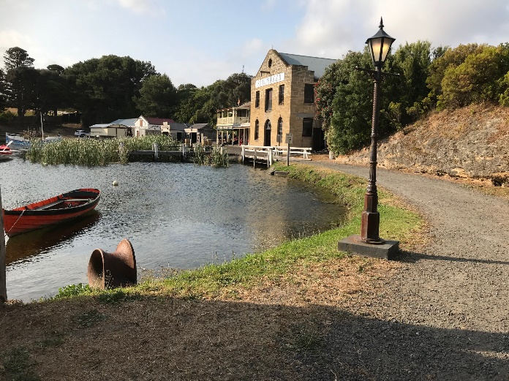
Before all this happened we were able to look at the village and we had a BBQ. The one memory we will all have of this night was the reduction in temperature, we were frozen!! As we waited in the auditorium for it to go dark, a certain member of the UK delegates got up and got s all singing!!!! We were good!!!! Waltzing Mathilda, this was followed by songs about kookaburras, the Macdonald song, My Bonnie Lies over the Ocean and we had Linda conducting us singing t in a “round” It has to be said we were very good at making our own entertainment.

Friday 17th January.

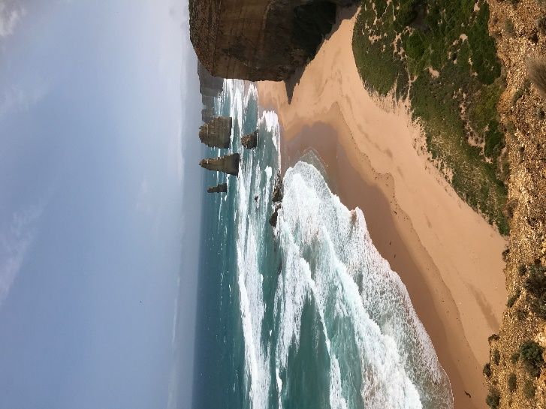
We were on the road a little later this morning. Our first visit of the day was to Cheeseworld . We had lunch here before heading off to our final stop before Melbourne.
We were travelling to Ballerat via the Great Ocean Rd. This had to be one of the High Lights of the trip. We stopped at the Twelve Apostles to take in the most spectacular view I have ever seen. We were lucky as the weather was beautiful and we had an amazing blue sky. The rugged coast was breath taking, with Wide Open Ocean and the waves splashing up on a very golden beach we just stared in complete amazement. Apparently some of the Apostles have fallen into the Ocean but there were still about 8 that could be seen. A short walk on the other side another side of the Apostles there was another massive stretch of coast it was vast. Only one word to describe this part of the Ocean Rd and that is MAGNIFICENT

In the late afternoon we arrived in Ballerat at the Mecure Hotel . After a quick freshen up we were back on the bus to Sovereign Hill. Here we travelled back in history to the days of the Gold Rush. Sovereign Hill is a village that has been re- constructed as a living museum with working exhibits. We were fortunate enough to experience the re-enactment of the gold rush we had a 3d film., a ride on a train and we were able to watch how the history of the Gold Rush unfolded and it became a very important part of Australian history.

Saturday 18th January

We arrived in the city of Mebourne in the late morning. Our hotel had an extraordinary name
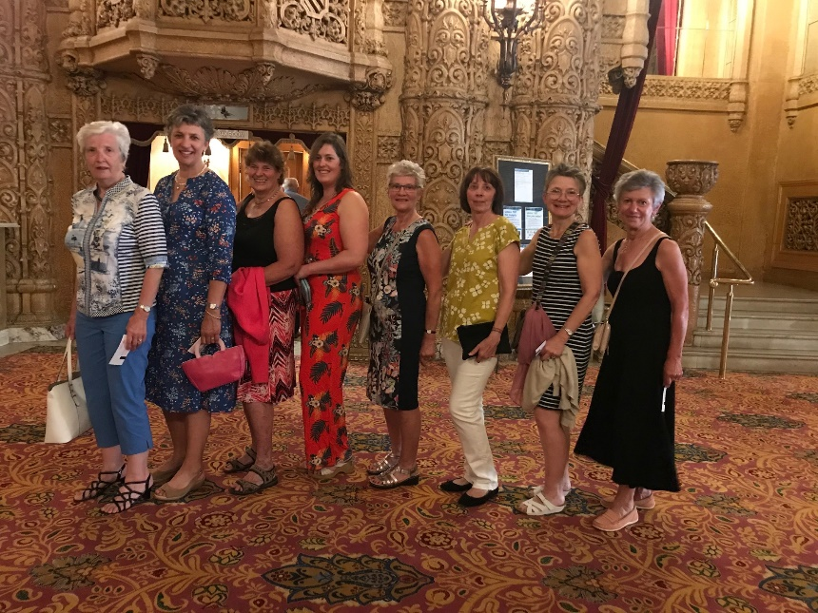
Batmans Hill on Collins. It was situated right in the middle of Melbourne. There were two options today, one was to visit the Gippsland area which was home of the Munden Family and their delightful farm. Originally the family came from New Zealand they set up farming Ayrshires Holsteins and Jerseys in Gippsland North Victoria.
The other Alternative was to explore Melbourne. It was easy to find our way round Melbourne with its very efficient tram system. The shops were beautiful, Window shopping was the name of the game as they were quite expensive.
Later in the afternoon we had a trip to the theatre to see War Horse. It was a fantastic performance, some tears but very enjoyable. The theatre was most palatial. It was a fabulous evening.

Sunday 19th January
This was a free day to explore this fascinating city. There was plenty to do. We met up with my niece and had lunch by the River, then went on a boat to Williamstown. We all met back at the Hotel and enjoyed chatting about our different experiences. Some had enjoyed the gardens, Queen Victoria Market and just enjoying a free day to wonder and take in the atmosphere of this very interesting city.

Monday 20th January.
Today we travelled to Shepparton. We arrived at the Parklake Hotel. After lunch we had the Conference Session with the Country presentations. The three main speakers were Dr Jennie Pryce who is a specialist in dairy genetics and genomics at the Universities of Victoria and La Trobe. David Kendall spoke he is the Director of Advancement, he is a member of the American Ayrshire Association Breed Improvement Committee. Michelle Axford who is the Genetic Evaluation Manager at DataGene. Each of the countries gave a report on the Ayrshire Societies in their countries including an excellent report from our own Claire Kim from the UK.
We had a pleasant evening at the hotel having dinner and chatting with friends.

Tuesday 21st January
The busses left early this morning as the International Dairy Week started at 8am. It started with the Ayrshire classes which were very big and well presented. The overall Champion was Hillcrest Ambush Bangle.
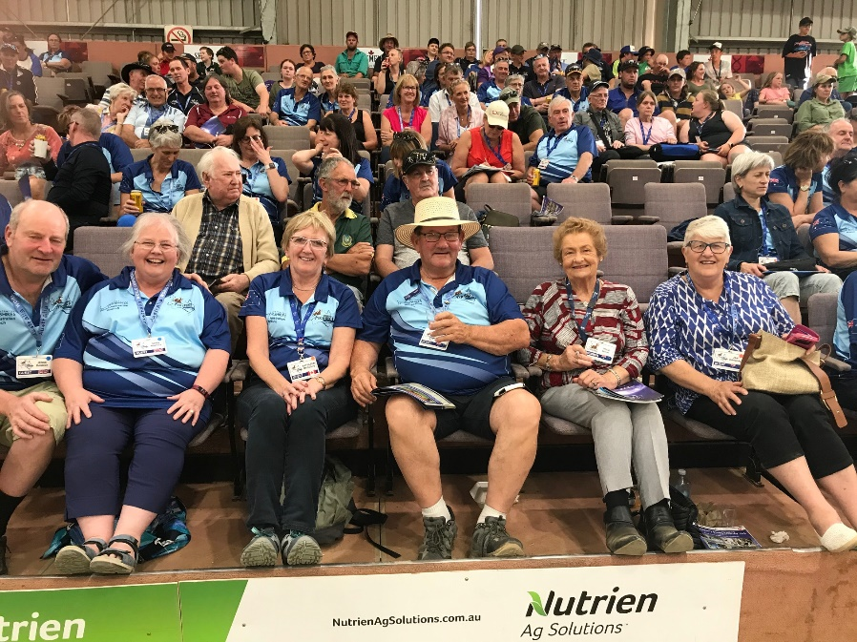
Some of the ladies decided to stay and have a chill day catching up with laundry. Later on in the afternoon the bus took us back to Tatura and we enjoyed watching the Ayrshire Sale. There were some very smart animals being sold. After the sale we had a BBQ at Wilson Hall. Sam and Vince were very brave and had all their locks cut off after super. They certainly looked very different. They raised a very handsome sum of money for Leukaemia.
Wednesday 22nd January
The bus took a party of delegates off to the show again this morning. There was an alternative trip today to the Historic wharf precinct Echuca. It was a very hot day. Along with Jan Edmonds and Ann Whitford we enjoyed a delightful cruise along the Murray River with a beautiful lunch on board. It was glorious ambling along. The Murray River is the principal river in Australia it is named after the Colonial Secretary Sir George Murray.
We then went back to the hotel to freshen up ready for the Conference Dinner at The Ballantine Centre we also had the finale of the Embryo Sale. This a delightful evening with a good food and great company.
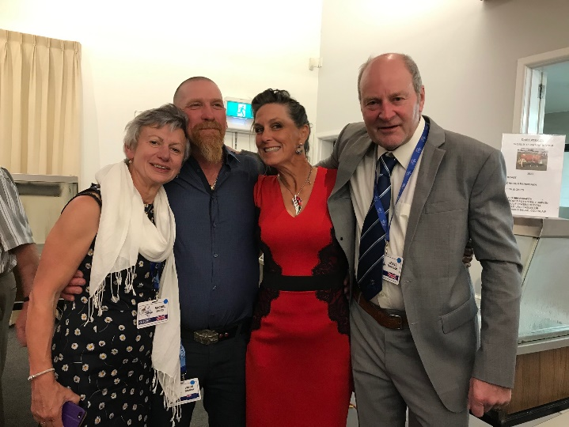
Thursday 23rd January
This was our last day in Shepparton, Over at International Dairy Week was the Holstein and All Breeds Show and the IDW wrap up. It was a good opportunity to have a good look round the town of Shepparton There lots of shops to look at and lots of large ornamental cows. There was a lovely park outside the hotel with a lake.
Tonight we had dinner in the hotel and this was the last night for some of our delegates, we had some Goodbyes which was very sad. 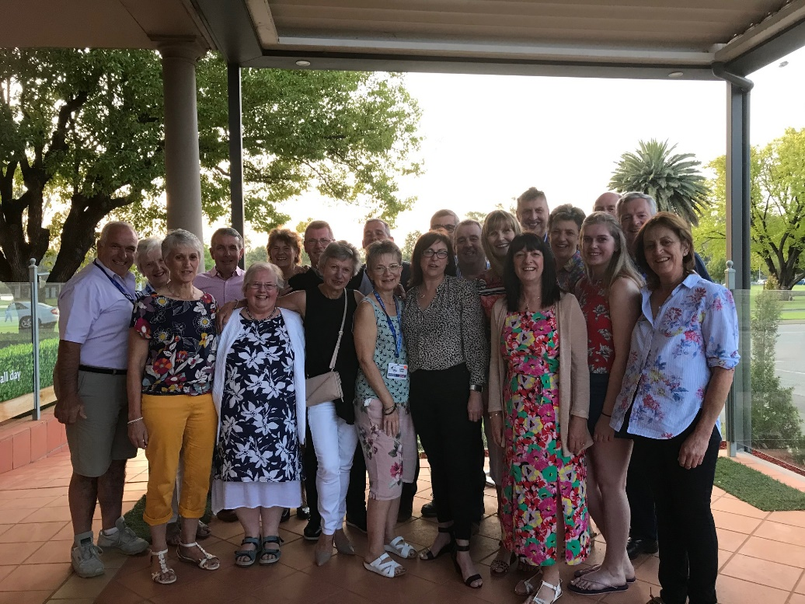

Friday 24th January
We left Shepparton in the morning and headed north to Jerildearie and Wagga Wagga. It was a very hot day but a very memorable one. We had been travelling quite a long way and we arrived at this Village Hall. It was a very homely spot we all felt it was like a scene out of “Thornbirds” Inside the hall were tables laid up with gorgeous salads, cake and tea. There were presentations set up with photographs and memorabilia of the farm we were about to visit. It was a little bit like an old fashioned Harvest Festival
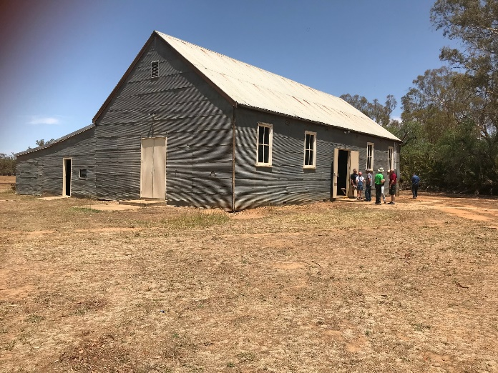
Not far from the Hall was the farm we were visiting Werombi and Werombi Vale. This is the home of Bret, Melinda, Amy, and Timothy Hayter. This is one of the oldest Ayrshire herds operating in Australia. The family have recently just relocated in October. It was an interesting afternoon looking round the farm and the milking parlour. We returned back to the village hall for tea.
Back on the road again we were heading for The Dickson Hotel in Canberra.
The evening was great we had dinner in the hotel. And afterwards when we all thought we’d go to bed! The party began there was a disco! The music got us all up dancing and Rocking all Over the World! The most amusing part of the evening was the DJ! DJ Sue she was a grey haired lady well in her 70s. Full of go, we all had a great time.

Saturday 25th January

Canberra is the Capital of Australia and our very knowledgeable bus drivers took us on an interesting tour of the city. We went up in the hills to start with, we viewed the city from a height. We got a marvellous view of the Parliament Building and the hills beyond, it was just slightly misty. This was not mist it was the remnants of the bush fires. We had see very little evidence of the bush fires. The news was telling us how very badly the fires had affected certain areas of the country. Homes had been lost, crops burnt and animals and wild life had lost their lives. WE were aware of these terrible tragedies but were lucky enough not to be have our Conference affected by these appalling fires.
Once down from the hills we went all around the all the Consulate Embassies they were all so different. Some were very ornate. We also saw the flags from all the countries from round the world. Canberra is not a huge city like Melbourne or Sydney, its compact and full of politician’s homes and their work places.
After visiting the Museum in Canberra, we went to Cockington Green Gardens, here we saw some of the most beautiful miniature English houses and gardens. They looked so real and all perfectly formed.
In the afternoon we enjoyed a couple of hours exploring the War Museum We saw the Australian War memorial and witnessed a very moving ceremony. A great many people congregated around the Memorial and a couple of families took part in this ceremony to remember an Uncle that had died during the First World War. It was very moving, not unlike we would have at home on Remembrance Day. I think everyone of our group were very taken in by this very poignant ceremony. It certainly very memorable.

Sunday 26th January
Today was Australia Day and we travelled to Carcour a small village that were celebrating the day in action! The atmosphere was lively, we had a really delicious BBQ at the Carcour Hotel that was in the middle of the village. They were old fashioned vintage cars and bicycles, lots of stalls and some people dressed up for the occasion. The village was very quaint with River running through. Families with small children were enjoying picnicking and paddling and thoroughly enjoying a family day out. Over a bridge there was old fashioned farm machinery, it was very warm. About 3.30 they all got ready for home. We got on the bus for the next leg of the journey which was a bit of a surprise.
We travelled to Bathhurst our hotel for the night was The Rydges Hotel. The surprise was it was located on a Motor Racing Track. For a treat our bus driver took us round the track!! Not at speed I might add!!! The hotel was amazing! We walked in through the bedroom door one side was a fitted kitchen, on the other side a large bathroom. The bedroom was huge with a King size bed, then a sofa Large French Window led out on to a balcony and a huge view over the race track!!!!
We enjoyed a lovely meal and after a very busy day an early night.

Monday 27th January
Today was a wonderful day as we packed in so many fabulous attractions.
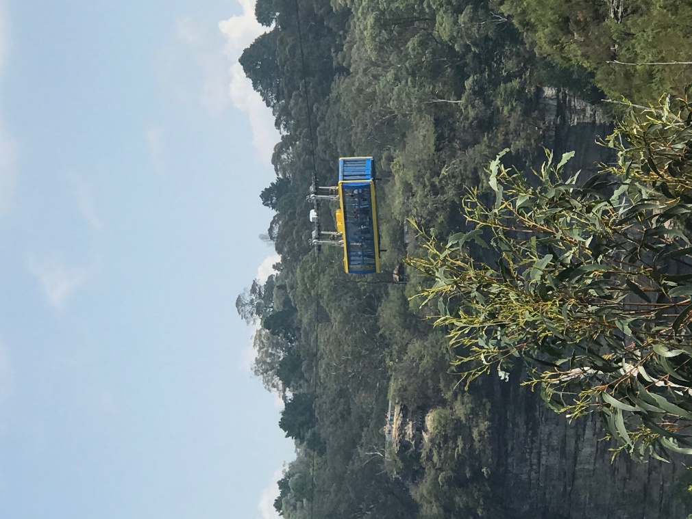
We departed from Bathurst and headed to the Blue Mountains. We arrived at Katoomba and spent the morning and early afternoon at Scenic World. WE had a great time, we went across this valley in a cable car with glass floor so we could see the Gorge beneath. Once we crossed the valley we could see the famous Three Sisters Peaks, we went for a lovely walk to take a good look at them. Our next adventure was the Scenic Railway, here we discovered the thrill of 52 degree incline in an open carriage, and it’s the steepest railway in the world.
We them went for an amazing walk though this rain forest, it was very warm but being under the trees made walking more pleasant. Walking through a rain forest is so atmospheric the colours are spectacular and the flora and fauna are in abundance. You can’t rush in case you miss something!! It was a thoroughly enjoyable trip.
It wasn’t a long journey after the Blue Mountains to Sydney. Very exciting arriving in this amazing city we’ve all herd so much about! Our hotel The Novatel was gorgeous and was to be our home for the last 3 nights of our Conference Tour.
The Novatel is situated on Darling Harbour. The evening was free for us all to explore. Down the road from the hotel was a ferry port. Here we got on the ferry and got our first glimpse of Sydney Harbour Bridge and a little further round the corner, there it was, one of the most photographed buildings that completely took my breathe away, Sydney Opera House. Whow what a wonderful sight.
We got off the boat and had a beautiful evening exploring this very interesting part of Sydney. We had dinner overlooking the Harbour Bridge and watching the people walking right across the top of the bridge. It was a real pleasure to be in this spectacular city.
Tuesday 28th January

Today we came out of the city of Sydney and travelled South through the National Park to Kiama. On the way we stopped for a comfort break right by cliffs. We were able to watch hand gliders jump of the cliff. It was fascinating to watch them fly around and eventually land safely on the ground.
We had lunch at the Bowling club in Kiama. Kiama is the home of the Australian Ayrshire Registration Centre and the Federation Office.
We then went on to Berry to the Mayfield Herd this the home of Paul and Vicki Tims and the Regal Park Ayrshires home of the Mayo family. The countryside was quite green in comparison to the other farms we had seen. It was a lovely spot and we were given some wonderful hospitality and a scrumptious afternoon tea in the garden.
We arrived back in Sydney and enjoyed a lovely evening with dinner on Darling Harbour.

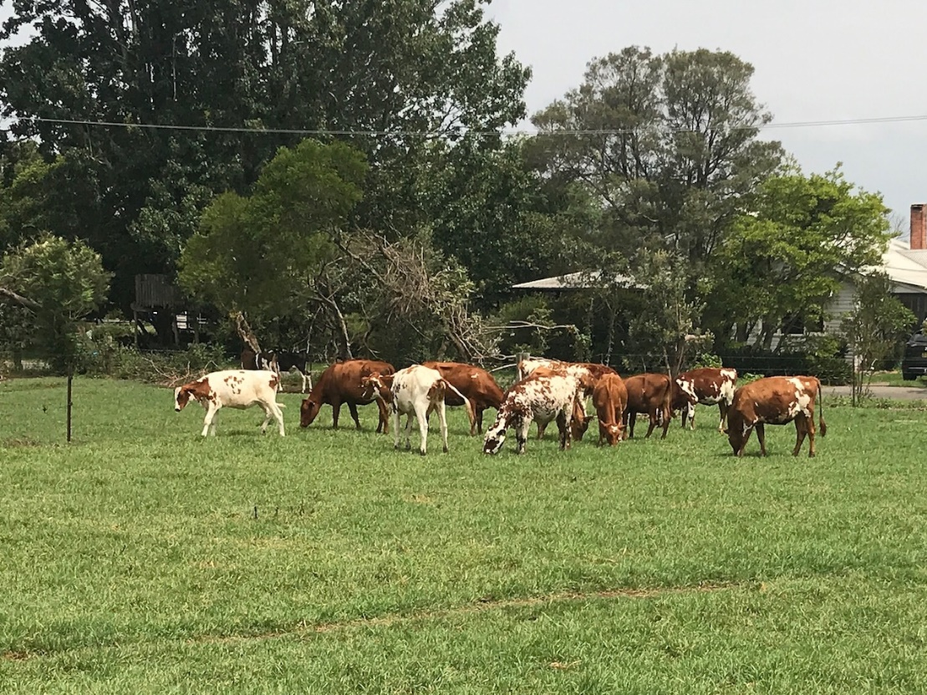

Wednesday 29th January
There was a herd visit to Woodburn Park this morning which quite a few delegates decided to join. Everyone said what a good day they had with some lovely countryside and some superb cows.
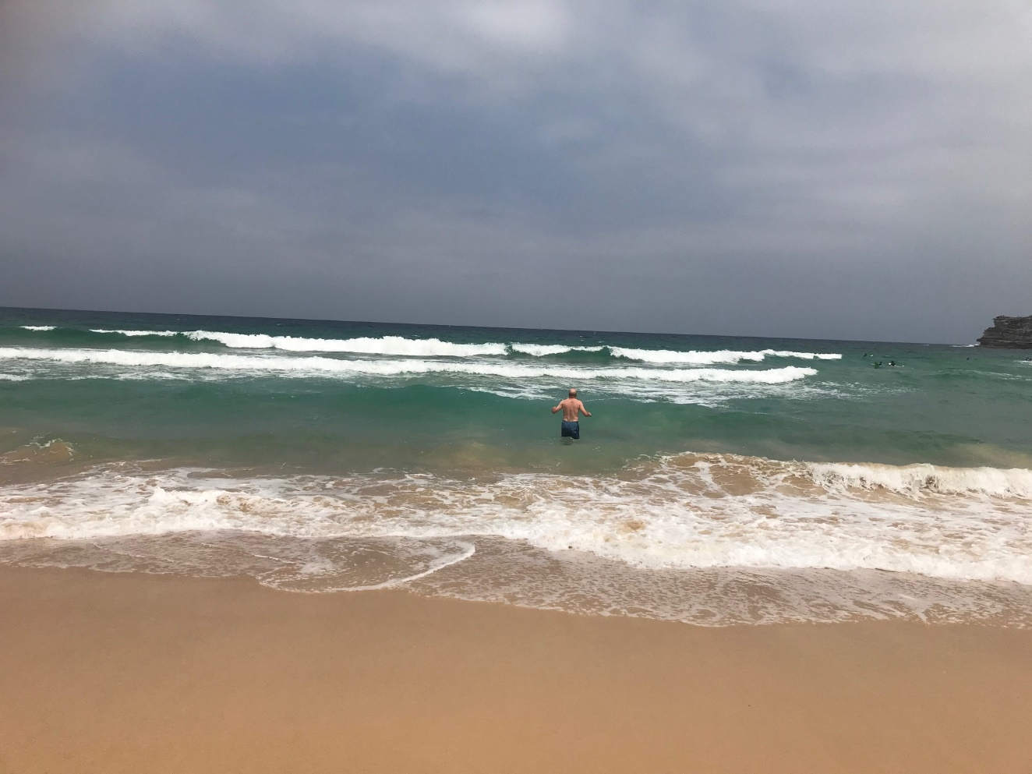
Alternatively it did leave a free day to explore the magnificent city of Sydney. Some of us took Big Bus Sydney for a tour around the city. Sitting on the top of the bus with headphones on, pointing out the various places of interest. Some people changed route on to the blue route and went to explore Bondi Beach!!! They even went to the trouble of leaving their wife in a fish restaurant. Telling her he was going the gents! Arriving back 20 minutes later in a pair of bathing trunks with Bondi Beach on the back. Then headed for the beach and the sea so he could say he had swam on Bondi Beach!!!!

Our last evening in Sydney was nothing less than spectacular! We went on an evening cruise around Sydney Harbour. We started having drinks and sailing around the harbour viewing the Harbour Bridge and that spectacular Opera House. We saw this wonderful building in all lights, as it went dark it lit up and was quite a spectacle. Lots of us had photos taken and for the last time we were able to enjoy the company of our dear friends from all over the world. We all felt like on big Ayrshire family. We had such a marvellous time with so many wonderful memories it was quite wrench saying goodbye to everyone. As the boat sailed on we could either dance the night away on board or go up on the top deck and take in the fantastic sights of Sydney and wave Au revoir to the Harbour Bridge and the Opera House.
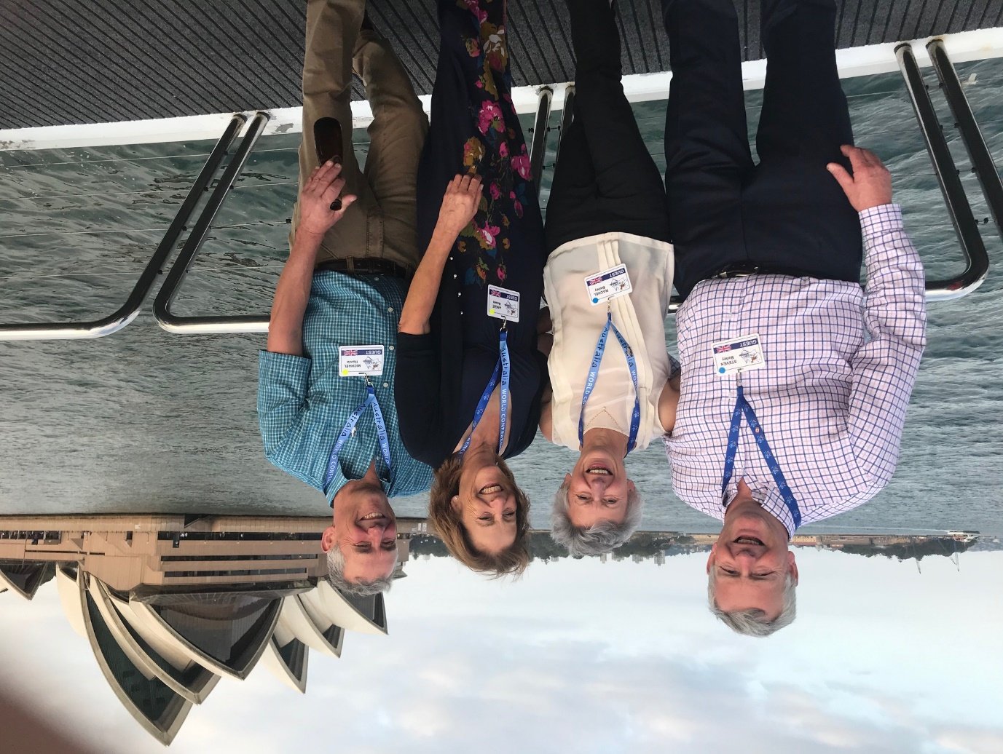
Thursday 30th January
Quite a few of the group had an early start to catch planes
However some of us did meet up at breakfast time. For some it was flights back home, others went on to explore New Zealand. We flew up to Brisbane to meet up with family and friends. We enjoyed a week in Mooloolaba exploring the Sunshine Coast, The Glass mountains and Australia Zoo.

This time in Australia has been an amazing experience. Our Australian hosts had planned the whole Conference with such care, attention to detail, some memorable places, very comfortable hotels delicious food. Considering we had travelled over a thousand miles our bus drivers their knowledge and the scenery was out of this world. I have come home having had a fantastic holiday and want to go back Australia soon!!!!

